**Home Assignment: 1 Promises in JavaScript**

**Objective**: Here, our aim is to be aware of how we handle/consume the promise

**Key points:**

* Handle promises using the .then() and.catch() approach
* Handle async code using the **await** keyword

**Reading documents:**

* Promise revision**:** <https://www.geeksforgeeks.org/javascript-promise/>
* Async/await: <https://www.programiz.com/javascript/async-await>

**Practice assignment Requirements:**

* We are adding a file in our repo that has enclosed promises or is an async function
* Now you just need to practice consuming those promises using both the approaches we discussed in today's class
  1. Using .then .catch
  2. Using async/await instead
* File for practice, .then and .catch => <https://github.com/testleaftrainings/Playwright_JS_Weekend_Tasks/blob/main/Homework/Week1/Day2/callbackWithPromies.js>
* File for practice async/await => <https://github.com/testleaftrainings/Playwright_JS_Weekend_Tasks/blob/main/Homework/Week1/Day2/callbackWithAsyncAwait.js>

**The expected flow in the script is:**

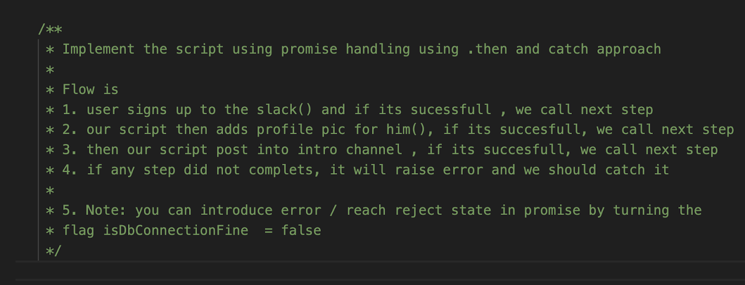

**Expected Outcome:**

Upon completion, you should be able to:

* Grasp the fundamental concepts of handling promises using two different approaches